ITopiaLogo

**Technical design**

*Project Virtualisation  
Team 2*

|  |  |  |  |
| --- | --- | --- | --- |
| **Client: Arjen Jansen** |  | **Filename:** | FD_v3.0.docx |
| **Project Virtualisation** |  | **Version:** | 3.1 |
| **Author:**  **Rami Haddad, Kasper van Brakel, Reinier van Rooij, Tim Dijkhuizen, Ingwar Verbeek** |  | **Date:** | 06-01-2015 |

# Document management

## History

| **Version** | **Date** | **Changes (draft/final)** | **Client** | **Author(s)** |
| --- | --- | --- | --- | --- |
| 1.0 | 29-09-2014 | Draft | Arjen Jansen | Rami Haddad, Kasper van Brakel, Reinier van Rooij, Tim Dijkhuizen, Rakis Bipat & Ingwar Verbeek |
| 2.0 | 05-12-2014 | Draft | Arjen Jansen | Rami Haddad, Kasper van Brakel, Reinier van Rooij, Tim Dijkhuizen, Ingwar Verbeek |
| 3.1 | 06-01-2014 | Draft | Arjen Jansen | Rami Haddad, Kasper van Brakel, Reinier van Rooij, Tim Dijkhuizen, Ingwar Verbeek |

## Approval

This document needs the following approvals.

Signed approval forms are stored in the Management section of the project archive.

|  |  |  |  |  |
| --- | --- | --- | --- | --- |
| **Name** | **Role** | **Signature** | **Date document** | **Version** |
|  |  |  |  |  |

# Table of contents

Document management 2

History 2

Approval 2

Table of contents 3

1. Introduction 4

2. Archimate 6

3. Network Design 7

4. Security 9

# Introduction

This document describes the technical specifications of the virtualization platform made by ITopia for Plaintech. The document consist of schematics, diagrams and explanations of the details. We will discuss the network, security and the system architecture in this document.

# Security

To ensure that the systems of Plaintech are fully secure we make use of several different methods and passwords. The proces of logging onto the main server requires a mobile authentication token as well as a password for each user. To then access the virtual machine through virt manager there is another specific password that must be used. If the administrator then wishes to open a virtual machine he must know the password configured by the client on the operating system. The client does not have to go through this long proces, the client only has to use his server IP address and VNC authentication code, then the client will be logged onto his/her server through an encypted cocnnection. The server’s firewall settings are configured correctly and that the least amount of ports are opened for VNC usage. The user has 5 attempts to log onto the server, 5 times access denied results in a 10 minute block, this is a security measure against script log in ( brute force attacks and other similar attacks ). We have tested the systems security to analyze the security which enabled us to achieve the desired result of a very well protected Plaintech environment.

# Network Design

Our network design includes standard firewalls between the routers and further internal network environment. The 2 thick red lines represent a firewall. The total network is split in two smaller networks. The first network consists of the Plaintech office pc’s, servers and routers. The second network is for the virtualization, it contains application servers, the storage area network and the back-up servers. The reason we made the decision to split the network in to two different networks is made because, the customers shouldn’t be able to connect to the Plaintech network. When there are 2 different networks it’s much harder to get in the network of Plaintech. You can see in this design that for every device there is a backup device. So whenever one of the devices break down, the backup will make sure the that the system won’t go down. 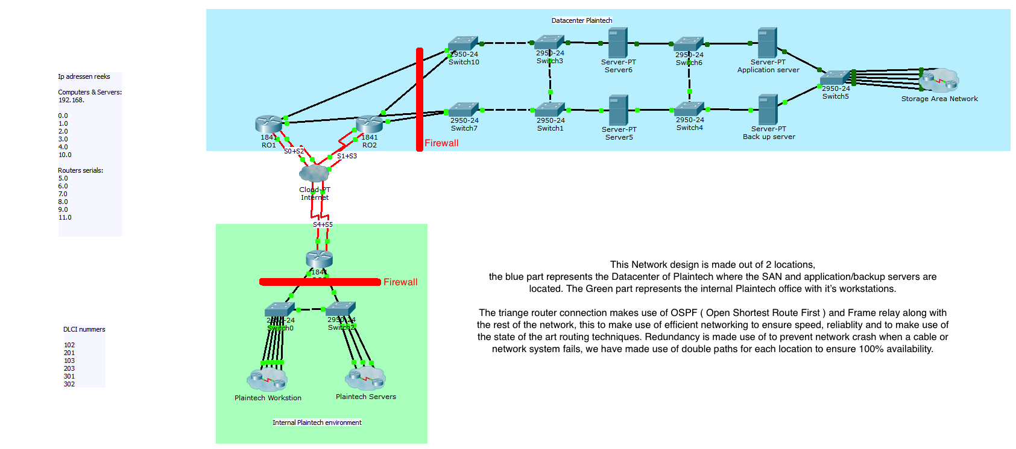

# Archimate

Figure 1 shows the architecture of the virtualization platform for Plaintech. The architecture is divided in 3 layers, the business layer, technical layer and the application layer. Within every layer there are different services to enable communication between the layers. For every process in the business layer there is shown which actors, will need to take action, to make the process possible.

# figuur 1